Circular Region

Definition
# Source: AI Source: Provided by: [Data Path: Persons Table -> ID Column: 1, Name_En Column: Motasem Essam] -> From: [ChatGPT] on [7/25/2026]
A Circular Region is a two-dimensional region of the plane whose boundary is formed entirely or partly by circles or circular arcs.
Circular regions may represent a complete filled circle, a portion of a circle, or a region between concentric circles.
A circular region is therefore a region, rather than merely a circular boundary.
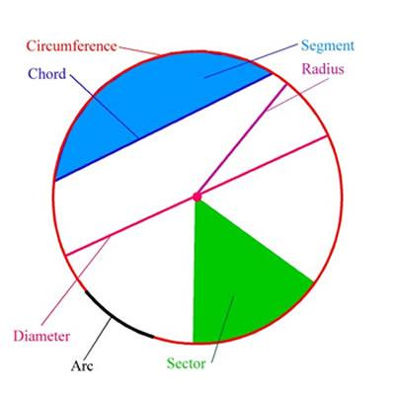
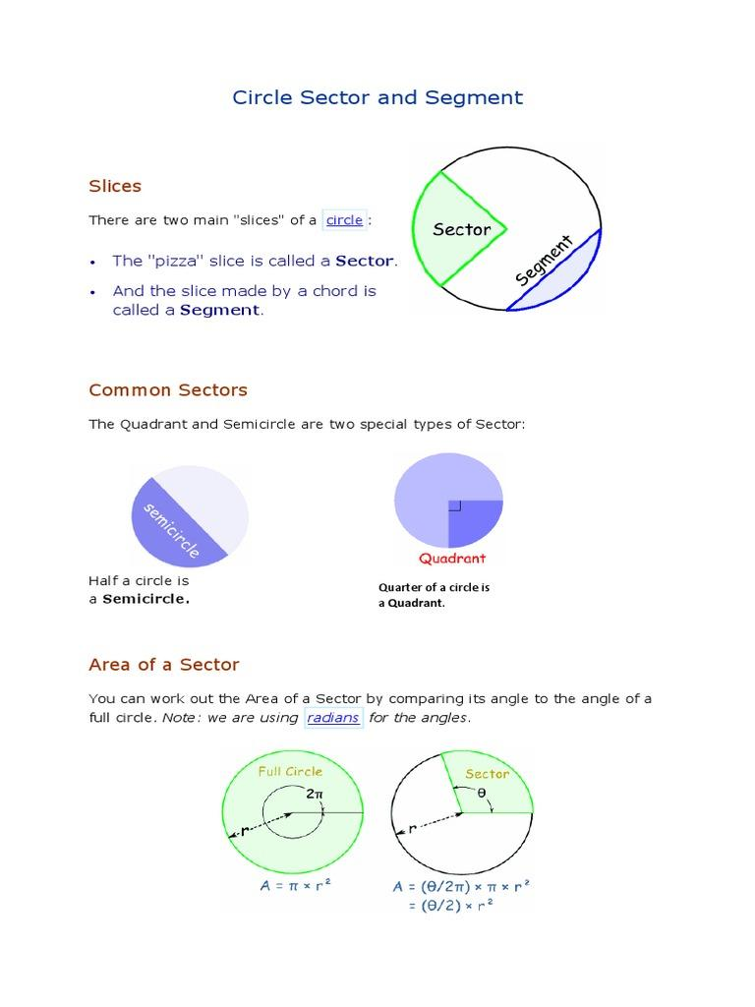
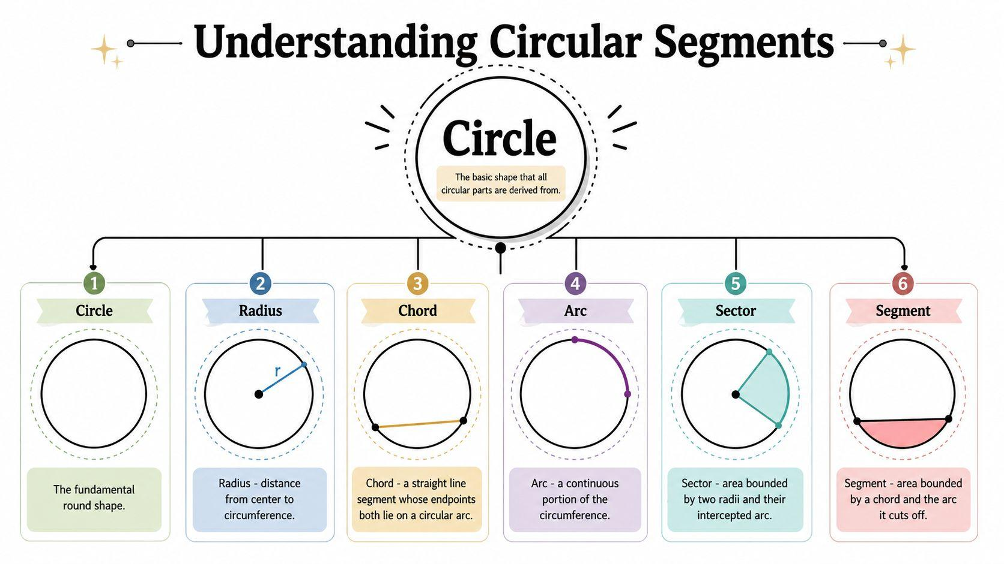

Fundamental Concept
# Source: AI Source: Provided by: [Data Path: Persons Table -> ID Column: 1, Name_En Column: Motasem Essam] -> From: [ChatGPT] on [7/25/2026]
A circular region is generally defined by one or more circular boundaries.
For example, a disk centered at $\left(h , k\right)$with radius $r$is:
$$\boxed{{\left(x-h\right)}^{2}+{\left(y-k\right)}^{2}≤r^{2}}$$
A region may also be bounded by circular arcs together with straight-line segments, as in a circular sector or circular segment.
The important distinction is:
$$\boxed{\text{Circular Region}=\text{2D Area/Region bounded by circular geometry}}$$
while:
$$\boxed{\text{Circle}=\text{1D Circular Curve}}$$

Main Characteristics
# Source: AI Source: Provided by: [Data Path: Persons Table -> ID Column: 1, Name_En Column: Motasem Essam] -> From: [ChatGPT] on [7/25/2026]
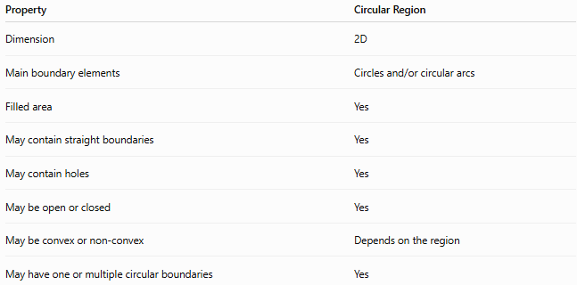
Property | Circular Region
Dimension | 2D
Main boundary elements | Circles and/or circular arcs
Filled area | Yes
May contain straight boundaries | Yes
May contain holes | Yes
May be open or closed | Yes
May be convex or non-convex | Depends on the region
May have one or multiple circular boundaries | Yes

Basic Structure
# Source: AI Source: Provided by: [Data Path: Persons Table -> ID Column: 1, Name_En Column: Motasem Essam] -> From: [ChatGPT] on [7/25/2026]
Circular regions can be classified according to how much of the circular geometry is used.
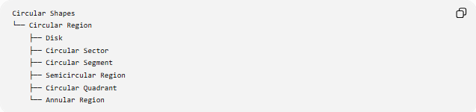
Circular Shapes
└── Circular Region
├── Disk
├── Circular Sector
├── Circular Segment
├── Semicircular Region
├── Circular Quadrant
└── Annular Region
This is a useful geometric classification, although some categories can overlap.
For example:
$$\boxed{\text{Circular Quadrant}⊂\text{Circular Sector}}$$
and:
$$\boxed{\text{Semicircular Region}⊂\text{Circular Sector}}$$
when the sector has a central angle of ${180}^{∘}$.

Types of Circular Region

1. Disk
# Source: AI Source: Provided by: [Data Path: Persons Table -> ID Column: 1, Name_En Column: Motasem Essam] -> From: [ChatGPT] on [7/25/2026]
A Disk is the complete filled region enclosed by a circle.
For a closed disk:
$$\boxed{{\left(x-h\right)}^{2}+{\left(y-k\right)}^{2}≤r^{2}}$$
Its area is:
$$\boxed{A=πr^{2}}$$
The disk can be further classified as:
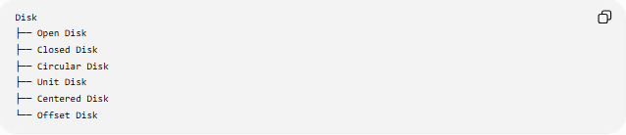
Disk
├── Open Disk
├── Closed Disk
├── Circular Disk
├── Unit Disk
├── Centered Disk
└── Offset Disk

2. Circular Sector
# Source: AI Source: Provided by: [Data Path: Persons Table -> ID Column: 1, Name_En Column: Motasem Essam] -> From: [ChatGPT] on [7/25/2026]
A Circular Sector is a region bounded by:
- Two radii
- One circular arc
It is the portion of a disk swept out by a central angle $θ$.
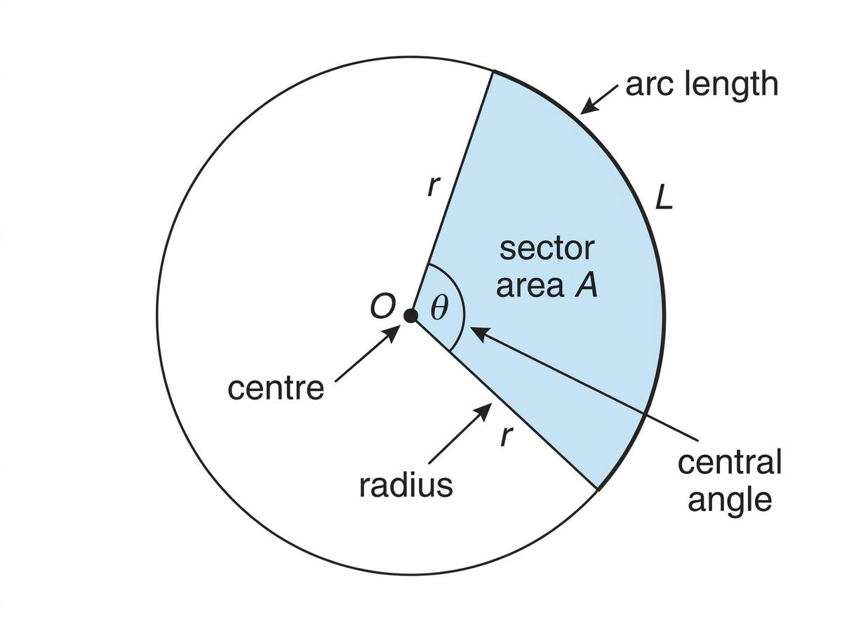
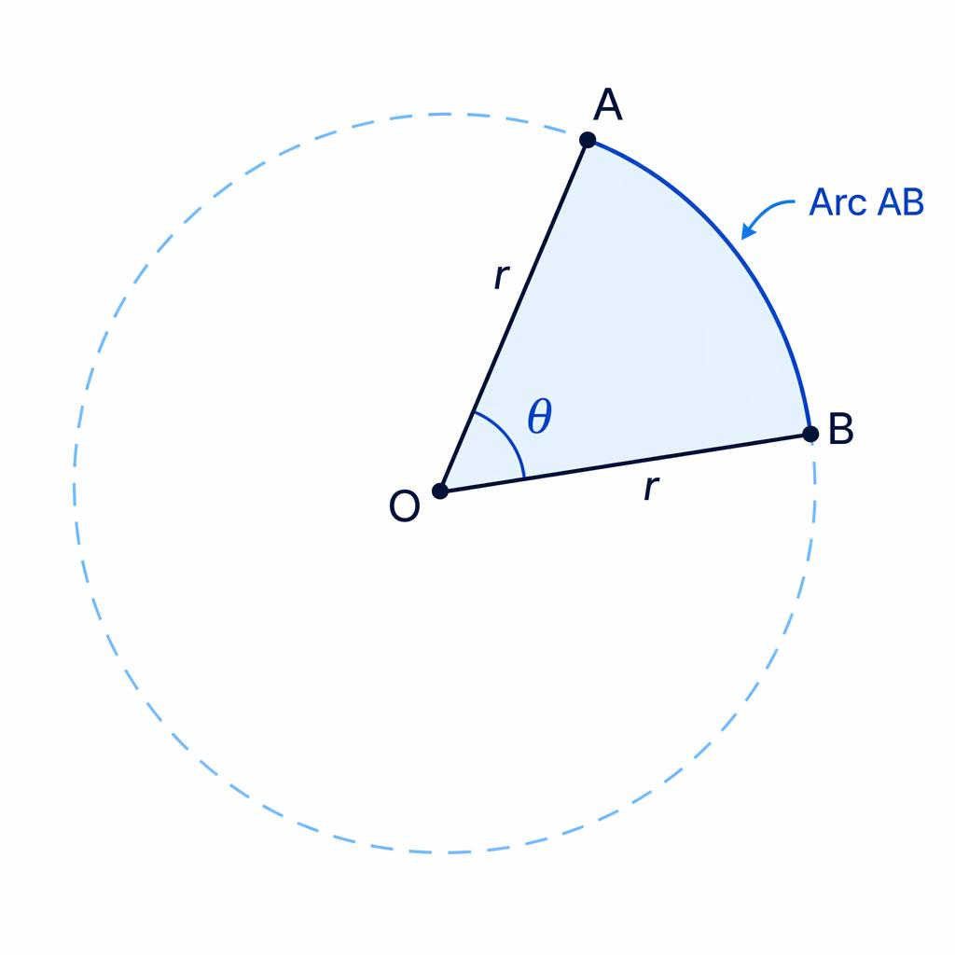
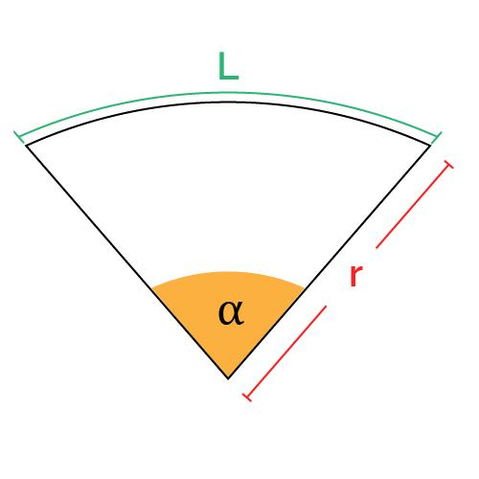
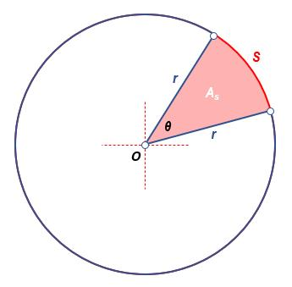
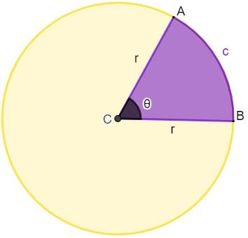
Area
For $θ$in radians:
$$\boxed{A=\frac{1}{2}r^{2}θ}$$
For $θ$in degrees:
$$\boxed{A=\frac{θ}{{360}^{∘}}πr^{2}}$$
Perimeter
$$\boxed{P=2r+rθ}$$
when $θ$is measured in radians.

3. Circular Segment
# Source: AI Source: Provided by: [Data Path: Persons Table -> ID Column: 1, Name_En Column: Motasem Essam] -> From: [ChatGPT] on [7/25/2026]
A Circular Segment is the region bounded by:
- A chord
- A circular arc
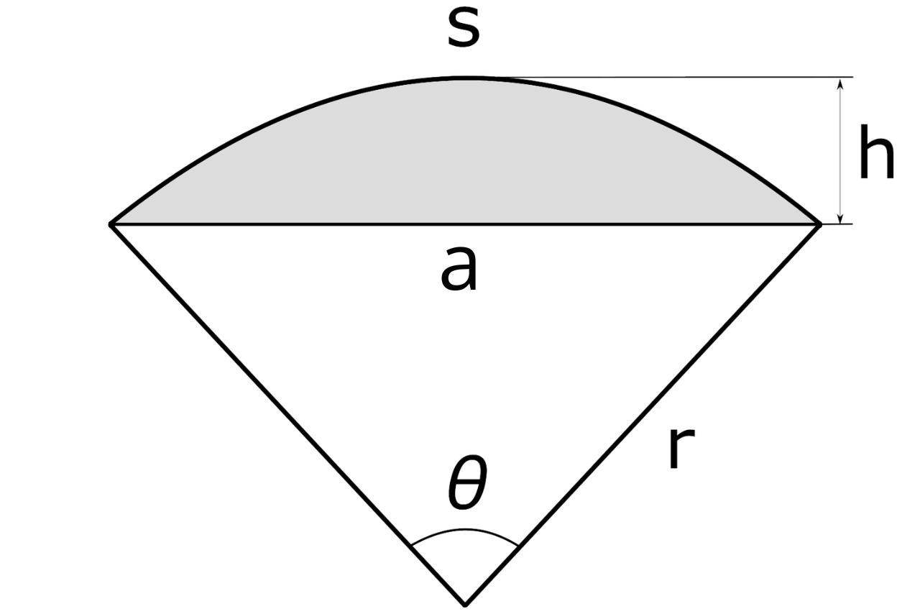
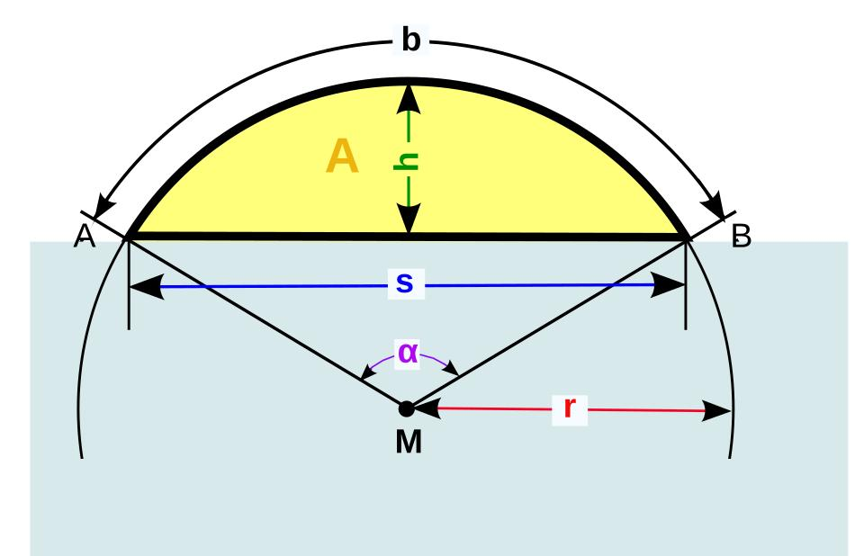
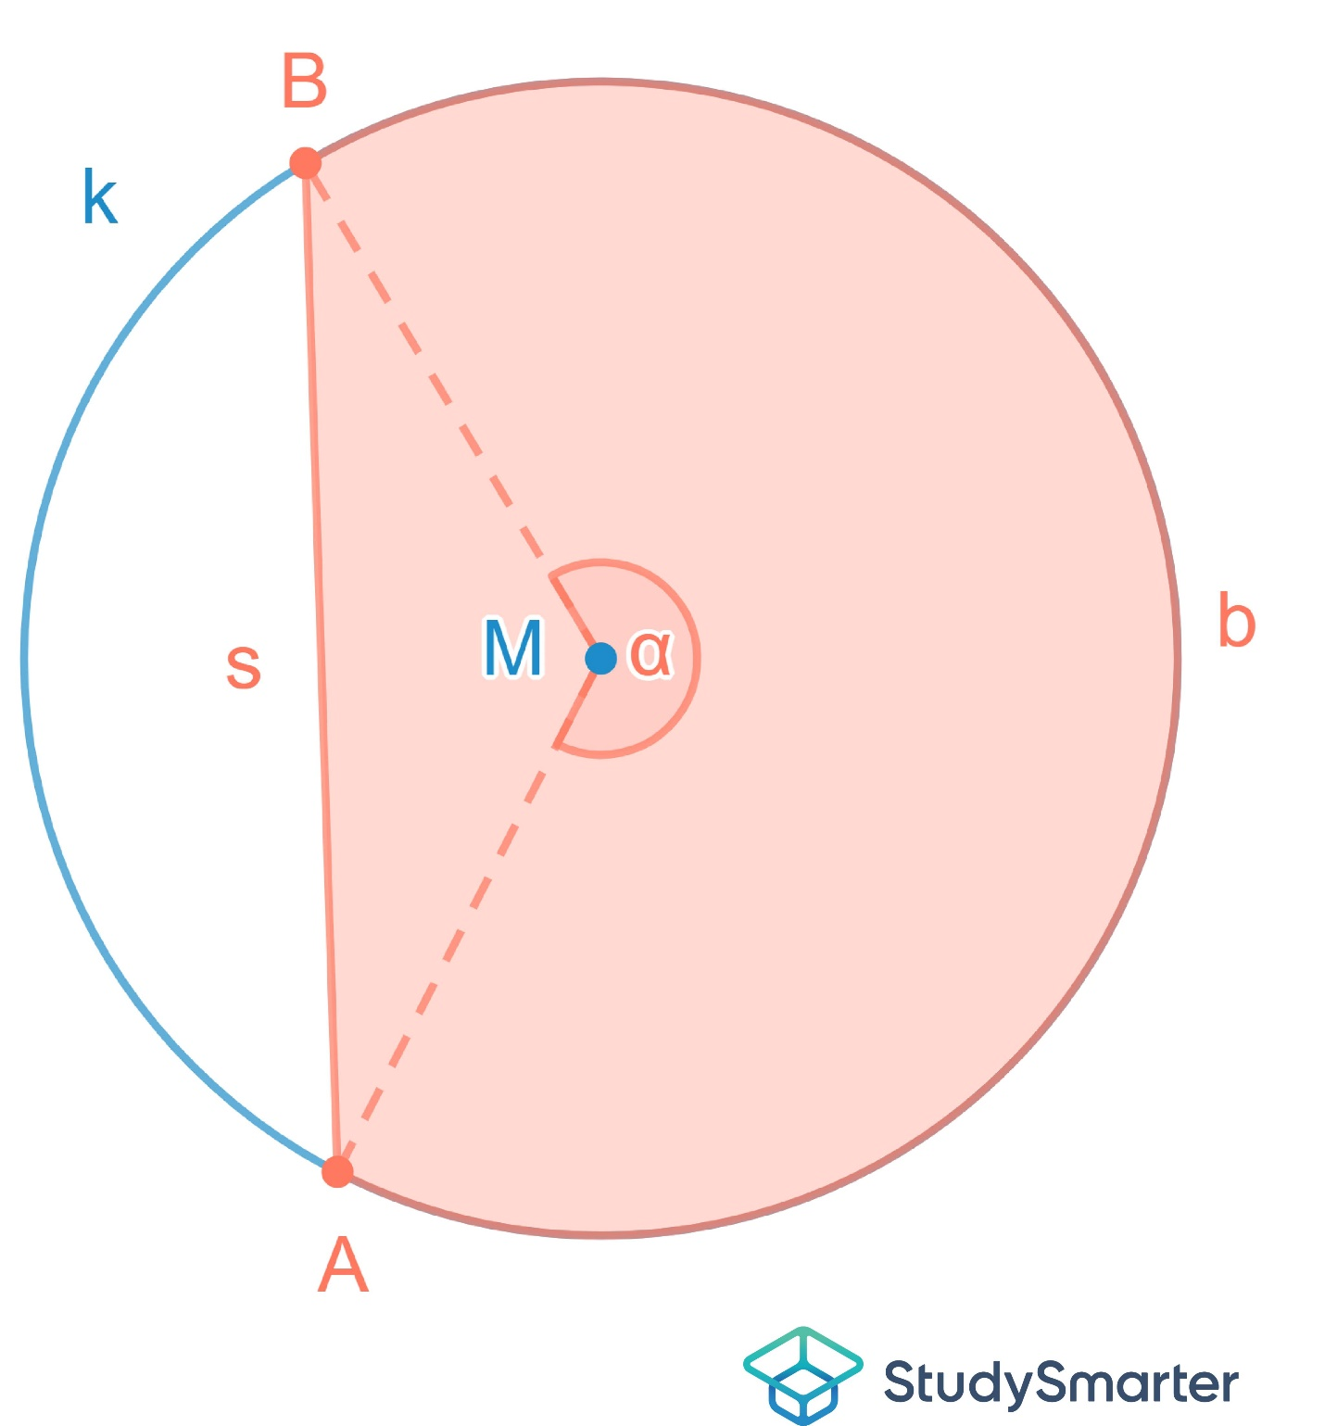
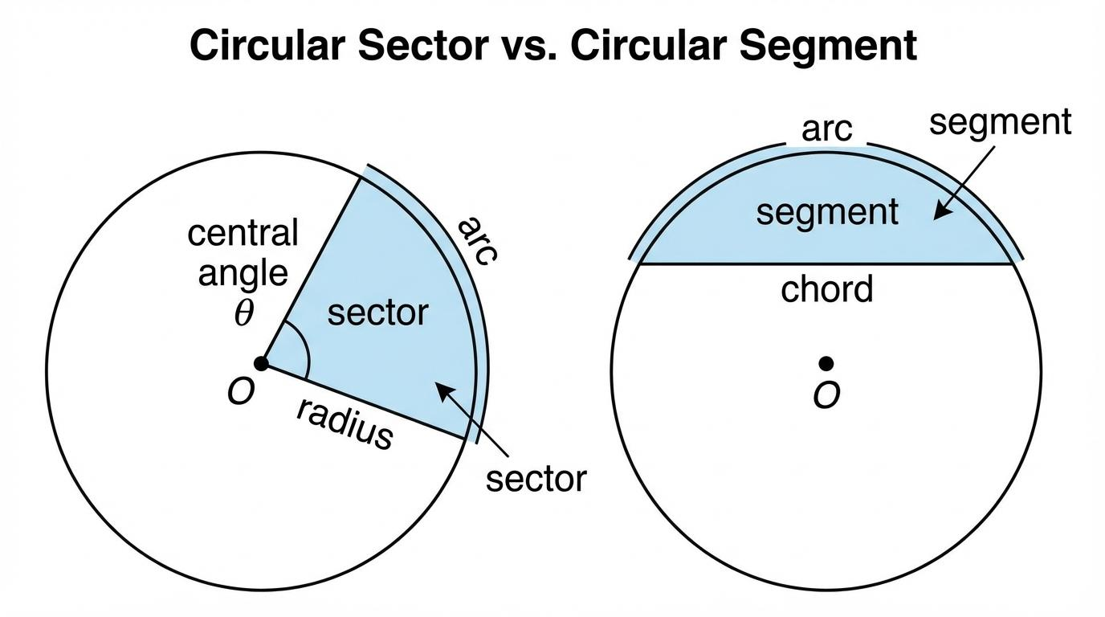
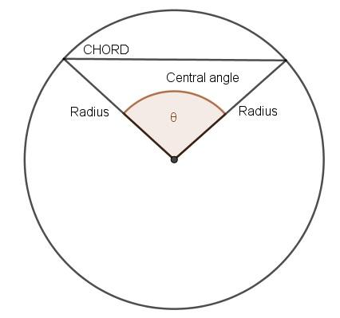
It differs from a sector because its straight boundary is a chord, not two radii.
For central angle $θ$in radians:
$$\boxed{A=\frac{1}{2}r^{2}\left(θ-\sin{θ}\right)}$$
The chord length is:
$$\boxed{c=2r\sin{\frac{θ}{2}}}$$

4. Semicircular Region
# Source: AI Source: Provided by: [Data Path: Persons Table -> ID Column: 1, Name_En Column: Motasem Essam] -> From: [ChatGPT] on [7/25/2026]
A Semicircular Region is half of a circular disk.
It is bounded by:
- A diameter
- A semicircular arc
Its central angle is:
$$\boxed{{180}^{∘}=π\text{ radians}}$$
Its area is:
$$\boxed{A=\frac{1}{2}πr^{2}}$$
It can be viewed as a special circular sector:
$$\boxed{\text{Semicircular Region}⊂\text{Circular Sector}}$$

5. Circular Quadrant
# Source: AI Source: Provided by: [Data Path: Persons Table -> ID Column: 1, Name_En Column: Motasem Essam] -> From: [ChatGPT] on [7/25/2026]
A Circular Quadrant is one quarter of a circular disk.
Its central angle is:
$$\boxed{{90}^{∘}=\frac{π}{2}}$$
It is bounded by:
- Two perpendicular radii
- A quarter-circle arc
Its area is:
$$\boxed{A=\frac{1}{4}πr^{2}}$$
Therefore:
$$\boxed{\text{Circular Quadrant}⊂\text{Circular Sector}}$$

6. Annular Region
# Source: AI Source: Provided by: [Data Path: Persons Table -> ID Column: 1, Name_En Column: Motasem Essam] -> From: [ChatGPT] on [7/25/2026]
An Annular Region is the region between two concentric circles.
The larger circle has radius $R$, and the smaller circle has radius $r$, where:
$$R>r>0.$$
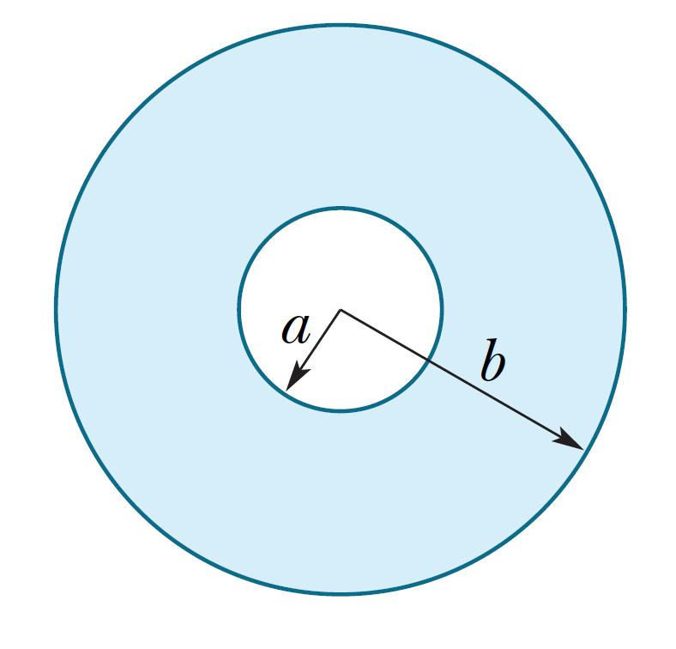
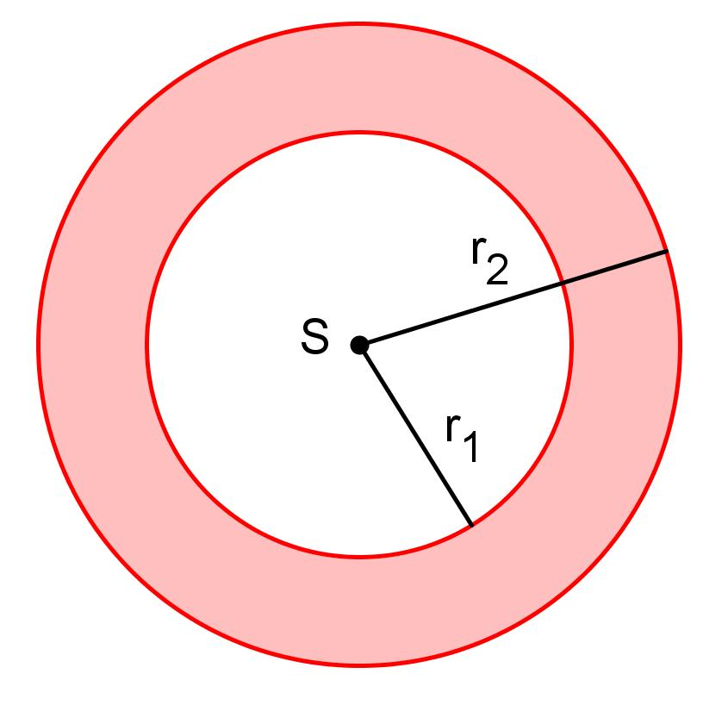
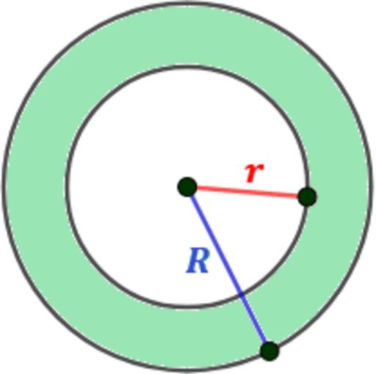
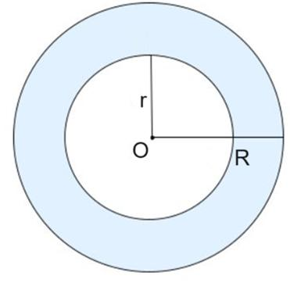
Its area is:
$$\boxed{A=π\left(R^{2}-r^{2}\right)}$$
Its radial thickness is:
$$\boxed{t=R-r}$$
An annular region may be classified into:
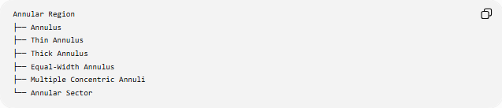
Annular Region
├── Annulus
├── Thin Annulus
├── Thick Annulus
├── Equal-Width Annulus
├── Multiple Concentric Annuli
└── Annular Sector

Annular Sector
# Source: AI Source: Provided by: [Data Path: Persons Table -> ID Column: 1, Name_En Column: Motasem Essam] -> From: [ChatGPT] on [7/25/2026]
An Annular Sector is a portion of an annulus.
It is bounded by:
- An outer circular arc
- An inner circular arc
- Two radial segments
For outer radius $R$, inner radius $r$, and central angle $θ$:
$$\boxed{A=\frac{1}{2}θ\left(R^{2}-r^{2}\right)}$$
where $θ$is in radians.
It can be understood as:
$$\boxed{\text{Annular Sector}=\text{Outer Sector}-\text{Inner Sector}}$$

Classification by Boundary
# Source: AI Source: Provided by: [Data Path: Persons Table -> ID Column: 1, Name_En Column: Motasem Essam] -> From: [ChatGPT] on [7/25/2026]
Another useful classification is based on the types of boundaries.
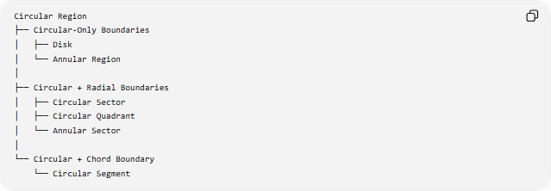
Circular Region
├── Circular-Only Boundaries
│ ├── Disk
│ └── Annular Region
│
├── Circular + Radial Boundaries
│ ├── Circular Sector
│ ├── Circular Quadrant
│ └── Annular Sector
│
└── Circular + Chord Boundary
└── Circular Segment
This classification helps distinguish regions that may otherwise look similar.

Classification by Number of Circular Boundaries
# Source: AI Source: Provided by: [Data Path: Persons Table -> ID Column: 1, Name_En Column: Motasem Essam] -> From: [ChatGPT] on [7/25/2026]
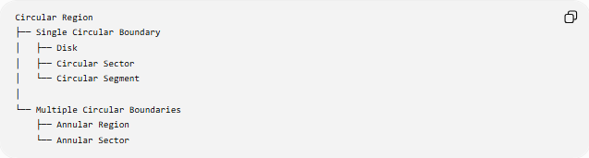
Circular Region
├── Single Circular Boundary
│ ├── Disk
│ ├── Circular Sector
│ └── Circular Segment
│
└── Multiple Circular Boundaries
├── Annular Region
└── Annular Sector
The number of circular boundaries is not the only distinction; straight boundaries may also be present.

Important Comparisons

Circular Region vs. Circle
# Source: AI Source: Provided by: [Data Path: Persons Table -> ID Column: 1, Name_En Column: Motasem Essam] -> From: [ChatGPT] on [7/25/2026]
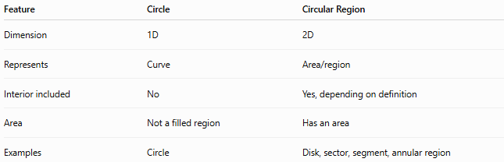
Feature | Circle | Circular Region
Dimension | 1D | 2D
Represents | Curve | Area/region
Interior included | No | Yes, depending on definition
Area | Not a filled region | Has an area
Examples | Circle | Disk, sector, segment, annular region
Thus:
$$\boxed{\text{Circle}≠\text{Circular Region}}$$
A circle may form the boundary of a circular region.

Disk vs. Circular Sector
# Source: AI Source: Provided by: [Data Path: Persons Table -> ID Column: 1, Name_En Column: Motasem Essam] -> From: [ChatGPT] on [7/25/2026]
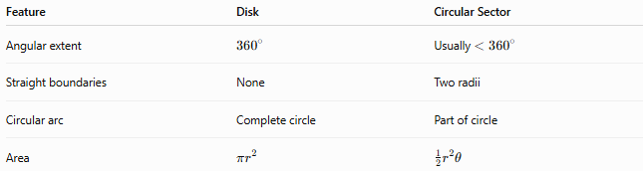
Feature | Disk | Circular Sector
Angular extent | $${360}^{∘}$$ | Usually $<{360}^{∘}$
Straight boundaries | None | Two radii
Circular arc | Complete circle | Part of circle
Area | $$πr^{2}$$ | $$\frac{1}{2}r^{2}θ$$

Sector vs. Segment
# Source: AI Source: Provided by: [Data Path: Persons Table -> ID Column: 1, Name_En Column: Motasem Essam] -> From: [ChatGPT] on [7/25/2026]
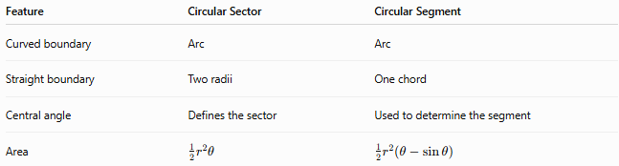
Feature | Circular Sector | Circular Segment
Curved boundary | Arc | Arc
Straight boundary | Two radii | One chord
Central angle | Defines the sector | Used to determine the segment
Area | $$\frac{1}{2}r^{2}θ$$ | $$\frac{1}{2}r^{2}\left(θ-\sin{θ}\right)$$
The fundamental distinction is:
$$\boxed{\text{Sector uses radii; Segment uses a chord}}$$

Disk vs. Annular Region
# Source: AI Source: Provided by: [Data Path: Persons Table -> ID Column: 1, Name_En Column: Motasem Essam] -> From: [ChatGPT] on [7/25/2026]
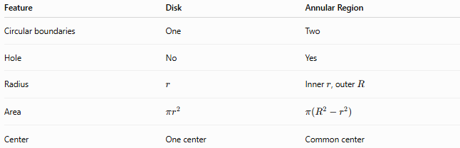
Feature | Disk | Annular Region
Circular boundaries | One | Two
Hole | No | Yes
Radius | $$r$$ | Inner $r$, outer $R$
Area | $$πr^{2}$$ | $$π\left(R^{2}-r^{2}\right)$$
Center | One center | Common center

General Mathematical Representation
# Source: AI Source: Provided by: [Data Path: Persons Table -> ID Column: 1, Name_En Column: Motasem Essam] -> From: [ChatGPT] on [7/25/2026]
Circular regions can be represented using Cartesian, polar, or parametric equations.
Cartesian
A disk:
$$\boxed{{\left(x-h\right)}^{2}+{\left(y-k\right)}^{2}≤r^{2}}$$
Polar
A centered disk:
$$\boxed{0≤ρ≤r}$$
An annular region:
$$\boxed{r≤ρ≤R}$$
An annular sector:
$$\boxed{r≤ρ≤R, θ_{1}≤θ≤θ_{2}}$$

Area Through Polar Coordinates
# Source: AI Source: Provided by: [Data Path: Persons Table -> ID Column: 1, Name_En Column: Motasem Essam] -> From: [ChatGPT] on [7/25/2026]
For a circular region described in polar coordinates, its area can generally be calculated using:
$$\boxed{A=\frac{1}{2}\int_{θ_{1}}^{θ_{2}}{\left[ρ_{\text{outer}}^{2}-ρ_{\text{inner}}^{2}\right]}dθ}$$
For an annular sector where the radii are constant:
$$ρ_{\text{outer}}=R, ρ_{\text{inner}}=r.$$
Therefore:
$$A=\frac{1}{2}\left(R^{2}-r^{2}\right)\left(θ_{2}-θ_{1}\right).$$

Key Classification Tree
# Source: AI Source: Provided by: [Data Path: Persons Table -> ID Column: 1, Name_En Column: Motasem Essam] -> From: [ChatGPT] on [7/25/2026]
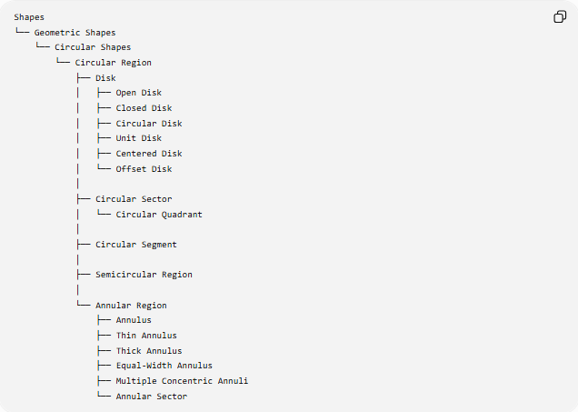
Shapes
└── Geometric Shapes
└── Circular Shapes
└── Circular Region
├── Disk
│ ├── Open Disk
│ ├── Closed Disk
│ ├── Circular Disk
│ ├── Unit Disk
│ ├── Centered Disk
│ └── Offset Disk
│
├── Circular Sector
│ └── Circular Quadrant
│
├── Circular Segment
│
├── Semicircular Region
│
└── Annular Region
├── Annulus
├── Thin Annulus
├── Thick Annulus
├── Equal-Width Annulus
├── Multiple Concentric Annuli
└── Annular Sector
Taxonomy note: Some names above, especially centered disk, offset disk, thin annulus, and thick annulus, are descriptive classifications rather than universally standardized mathematical categories. The core standard geometric regions are disk, sector, segment, semicircular region, annulus, and annular sector.

Key Points
# Source: AI Source: Provided by: [Data Path: Persons Table -> ID Column: 1, Name_En Column: Motasem Essam] -> From: [ChatGPT] on [7/25/2026]
- A circular region is a two-dimensional region associated with circular boundaries or circular arcs.
- A disk is the complete filled circular region.
- A sector is bounded by two radii and an arc.
- A segment is bounded by a chord and an arc.
- A semicircular region is half of a disk.
- A circular quadrant is one quarter of a disk.
- An annular region is the region between two concentric circles.
- An annular sector is a portion of an annular region.
- Circular regions may contain both curved and straight boundaries.
- A circle is a curve, whereas a circular region is a two-dimensional region.

Conclusion
# Source: AI Source: Provided by: [Data Path: Persons Table -> ID Column: 1, Name_En Column: Motasem Essam] -> From: [ChatGPT] on [7/25/2026]
A Circular Region is a two-dimensional geometric region associated with circles and circular arcs. Its main forms include:
$$\boxed{\text{Disk, Sector, Segment, Semicircular Region, Annular Region, Annular Sector}}$$
They can be distinguished primarily by their boundary structure, angular extent, number of circular boundaries, and presence of straight boundaries.

